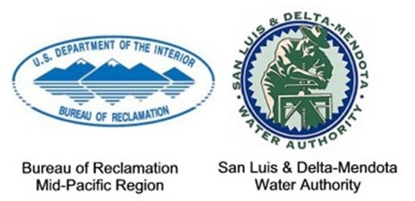
MP-15-033
Media Contacts:
(Reclamation) Erin Curtis, 916-978-5100, eccurtis@usbr.gov
(SLDMWA) Frances Mizuno, 209-832-6200, frances.mizuno@sldmwa.org

For Release On: March 20, 2015
Reclamation Releases Environmental Documents for Proposed Long-Term Water Transfers from 2015 to 2024
SACRAMENTO, Calif. – The Bureau of Reclamation and San Luis & Delta-Mendota Water Authority today released the Final Environmental Impact Statement/Report on the effects of long-term water transfers from 2015 to 2024. The project is aimed at providing water users with immediately implementable and flexible water supplies to help alleviate shortages due to drought.
The project facilitates voluntary water transfers from willing sellers north of the Delta to willing buyers south of the Delta and in the San Francisco Bay Area. The transfers consist of Central Valley Project or non-CVP water that would be conveyed through CVP or State Water Project facilities.
Reclamation will not make a decision on the proposed action until at least 30 days after release of the Final EIS/R; Reclamation will then complete a Record of Decision. The ROD will state the action that will be implemented and will discuss all factors leading to the decision.
Reclamation and SLDMWA are the lead federal and state agencies, respectively, for the National Environmental Policy Act and the California Environmental Quality Act. The Final EIS/R is available at http://www.usbr.gov/mp/nepa/nepa_projdetails.cfm?Project_ID=18361. If you have problems accessing the document online, please call 916-978-5100 (TTY 800-877-8339) or email mppublicaffairs@usbr.gov.
Copies of the Final EIS/R are available for public review at the following locations: (1) Reclamation, Mid-Pacific Region, Regional Library, 2800 Cottage Way, Sacramento, CA 95825, (2) Natural Resources Library, Department of the Interior, 1849 C Street NW, Main Interior Building, Washington, DC 20240, (3) SLDMWA, 842 6th Street, Los Banos, CA 93635.
For additional information, please contact Brad Hubbard, Reclamation, at 916-978-5204 (TTY 800-877-8339) or Frances Mizuno, SLDMWA, at 209-832-6200 or P.O. Box 2157, Los Banos, CA, 93635.
# # #
Reclamation is the largest wholesale water supplier and the second largest producer of hydroelectric power in the United States, with operations and facilities in the 17 Western States. Its facilities also provide substantial flood control, recreation, and fish and wildlife benefits. Visit our website at http://www.usbr.gov.

